03 • STUDENT TEMPLATE

Software Requirements Specification Draft
กรอกตามหลักฐาน • รักษา ID • เปิดเผย TBD • ตรวจ trace
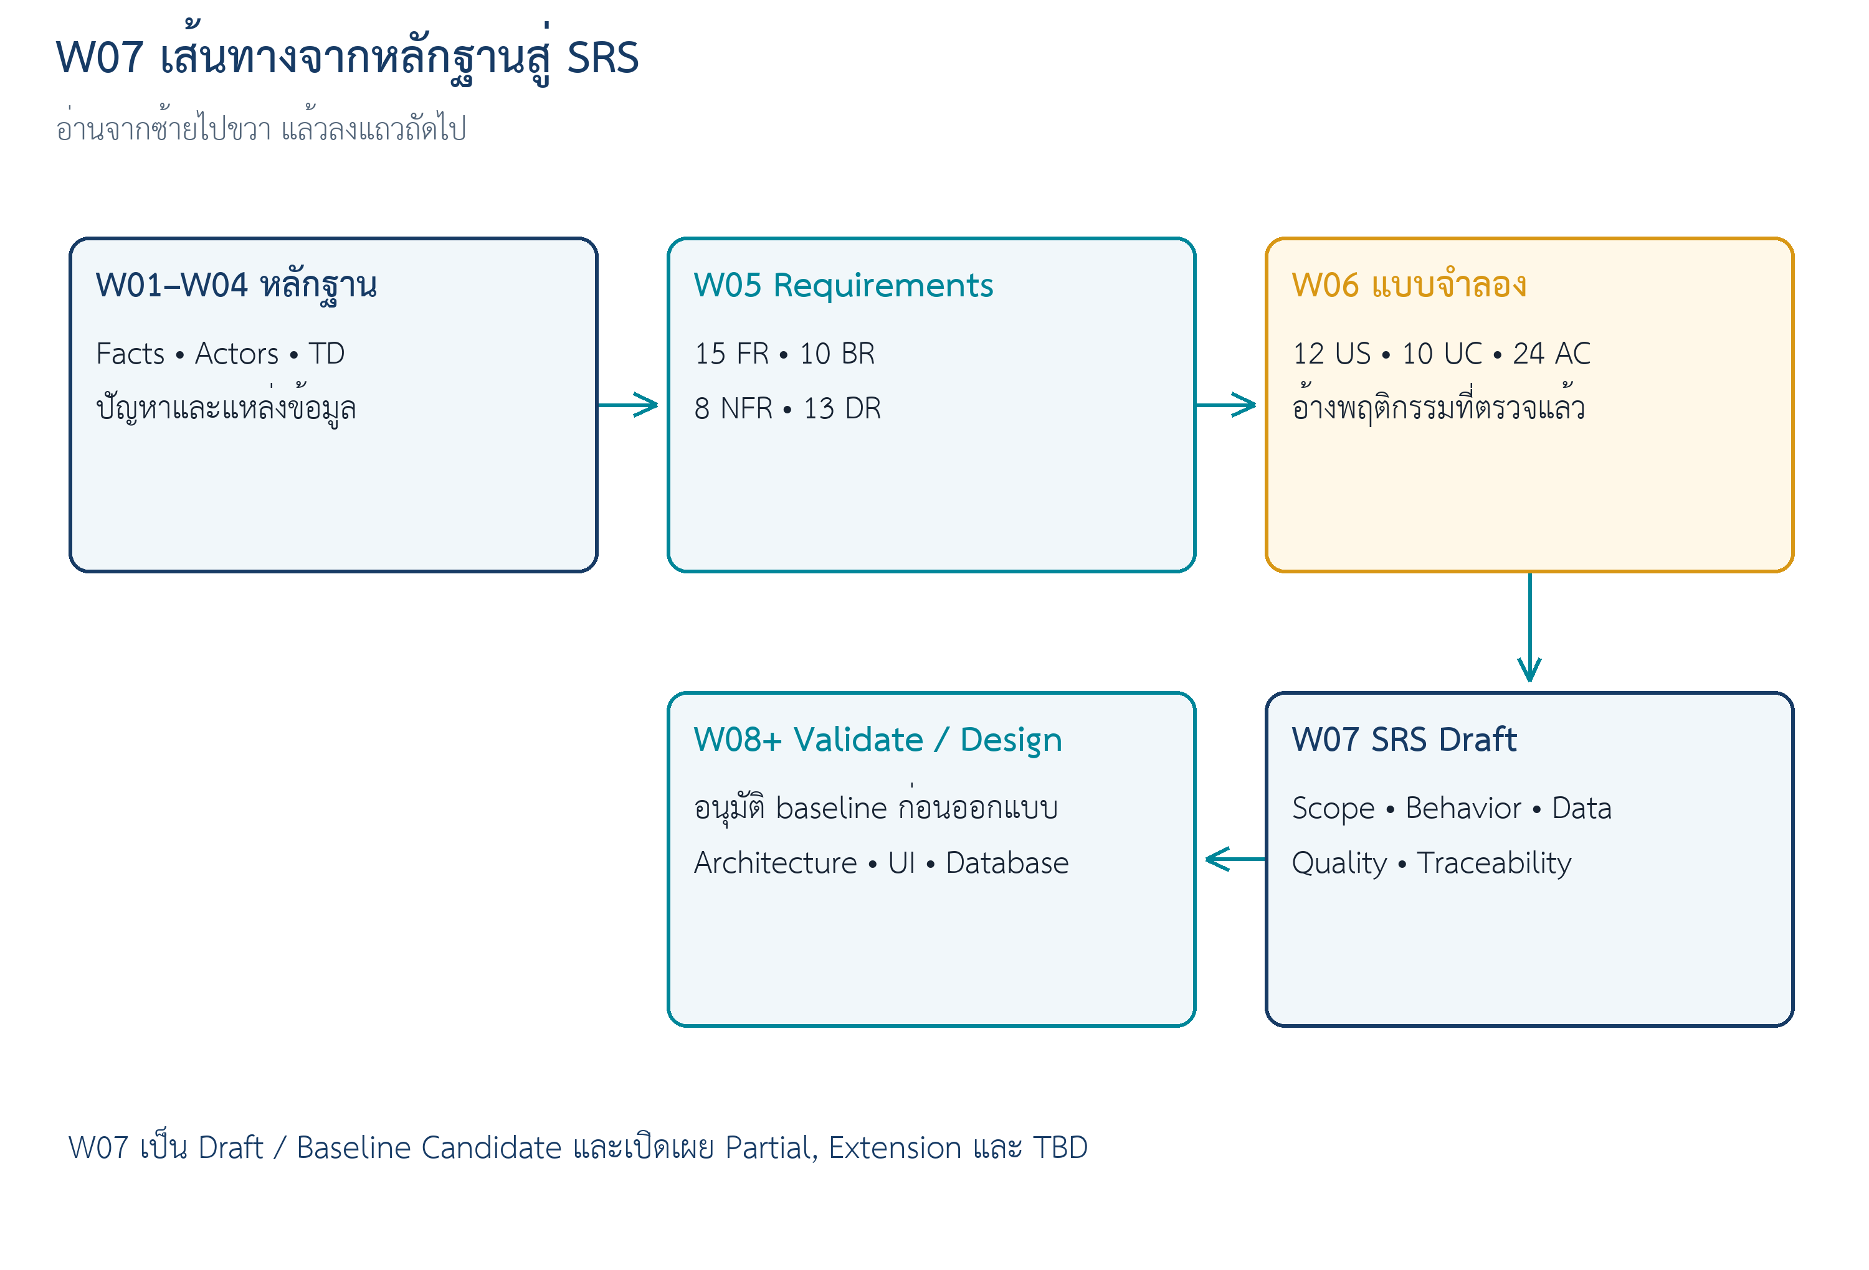
สถานะ | บทบาท | Input Contract
Production Candidate | Student editable template | W05 v1.1 + W06 completed model

ชุดตรวจอาจารย์ • SRS ยังเป็น Baseline Candidate • ยังไม่รวมเข้า Course Repo

START HERE

วิธีใช้ Template
- แทนข้อความในวงเล็บเหลี่ยมด้วยข้อมูลจาก case และ source ที่ตรวจแล้ว
- ห้ามลบ requirement ที่ยังไม่ทำ ให้เลือก Deferred/Extension/Issue พร้อมเหตุผล
- เลือก Functional Requirement 2–3 ข้อเขียน Detailed Record; ข้อที่เหลือใช้ตารางย่อแต่ต้องมี disposition
- ห้ามกำหนด performance, retention, RPO/RTO หรือ interface detail ที่ไม่มีหลักฐาน
- ส่งเอกสารเป็น Draft/Baseline Candidate เพื่อ review ใน Week08
SOURCE SNAPSHOT  PASS เมื่อครบทุกข้อ | ☐ [W05 version/path]  ☐ [W06 version/path]  ☐ [commit/hash or dated snapshot]  ☐ [known Partial/Extension/TBD]

0. Document Control
Field | Student entry
Case ID | [CASE-ID]
Document ID | [CASE-ID]-SRS-W07-v1
Version | 0.1-draft
Status | Draft / Baseline Candidate
Team/Owner | [team]
Source snapshot | [W05/W06 artifact + commit/hash]
Updated | [YYYY-MM-DD]

1. Introduction

1.1 Purpose
[เอกสารนี้กำหนดอะไร ใครใช้ และส่งต่อไปทำอะไร]

1.2 Problem and Goals
Goal | Desired outcome | Source | Status
[G-xx] | [outcome] | [source ID] | Fact / TD / Assumption

1.3 Product Scope
In Scope | Out of Scope / Extension | Reason/source
[capability] | [excluded or extension item] | [why/source]

1.4 Definitions
Term | Meaning | Source/Decision
[term] | [business meaning] | [source]

2. Overall Description

2.1 Product Context
[อธิบาย system boundary, system of record และภาพ context โดยไม่เลือก technology]

2.2 User Classes and Authority
Actor | Goal | Authorized actions | Restrictions | Source
[ACT-xx] | [goal] | [actions] | [limits] | [source]

2.3 Capabilities
CAP | Capability | Requirement families | W06 model | Coverage
[CAP-xx] | [name] | [FR/BR/NFR/DR] | [US/UC/AC] | [Detailed/Partial]

2.4 Constraints and Assumptions
ID | Type | Statement | Source | Status/next action
[CT/AS-xx] | [type] | [statement] | [source] | [status]

2.5 External Interfaces
ID | System | Data/direction | Core/Extension | TBD/failure concern
[EXT-xx] | [name] | [exchange] | [scope] | [unknown]

3. Functional Requirements
จัดกลุ่มตาม capability/workflow และทำซ้ำตาราง Detailed Record สำหรับ 2–3 requirements ที่เลือกตรวจลึก

3.x [Capability] — Summary
FR | Requirement | Source | Priority/admission | US/UC/AC | Status
[FR-xx] | ระบบต้อง… | [F/E/TD] | [Must/Core] | [IDs] | [Ready/Partial/TBD]

3.x.y Detailed Requirement Record
Field | Student entry
Requirement ID | [FR-xx]
Statement | ระบบต้อง…
Rationale/Goal | [G-xx / why]
Source | [F/E/TD]
Priority/Admission | [Must/Should/Could] / [Core/Supporting/Extension]
Trigger | [observable event]
Preconditions/guards | [state/rule]
Expected result | [observable state/data/event]
BR/NFR/DR links | [IDs]
US/UC/AC links | [IDs]
Verification | [method + scenario]
Status/TBD | [status + missing evidence]

4. Business Rules
BR | Rule | Authority/source | Affected FR/UC | Status
[BR-xx] | [rule] | [TD/source] | [IDs] | [confirmed/TBD]

5. Non-functional Requirements
NFR | Quality statement | Context/stimulus | Response/measure | Source | Verification | Status/TBD
[NFR-xx] | ระบบต้อง… | [when/context] | [measure or TBD] | [source] | [method] | [status]

6. Data Requirements
ส่วนนี้เป็น conceptual data requirement ยังไม่กำหนด table, column type, foreign key, index หรือ API payload
DR | Concept | Requirement/minimum data | Relationships | Classification | Source | Status
[DR-xx] | [concept] | [meaning + minimum data] | [concept links] | [class] | [IDs] | [ready/TBD]

7. Behavioral Model References
Model | IDs/version | Requirement anchors | Coverage/gap | SRS use
User Stories | [US-*] | [FR/BR/NFR/DR] | [coverage] | [section]
Use Cases | [UC-*] | [FR/BR/NFR/DR] | [level] | [section]
Acceptance Criteria | [AC-*] | [FR/BR/NFR/DR] | [covered/gap] | [verification]

7.1 Lifecycle Rules
From | Trigger | To | Guard/result | Source
[state] | [event] | [state] | [guard] | [ID]

8. External Interface Requirements
Interface | Requirement/data | Direction | Owner | Failure/privacy concern | Status
[EXT-xx] | [what] | [in/out] | [owner] | [concern] | [Core/Extension/TBD]

9. Traceability and Coverage
Source | W05 requirement | W06 model | SRS section | Verification | Coverage
[F/E/TD] | [FR/BR/NFR/DR] | [US/UC/AC] | [หัวข้อ ] | [VF/method] | [Covered/Partial]

10. Open Issues
OI | Question/TBD | Affected IDs | Owner | Next action | Expected evidence | Needed by
[OI-xx] | [unknown] | [IDs] | [role] | [action] | [evidence] | [milestone]

11. Verification Plan
VF | Method | Target IDs | Procedure/evidence | Owner | Status
[VF-xx] | [Review/Demo/Test/Analysis] | [IDs] | [how/evidence] | [owner] | [planned]

12. Review Gate
BASELINE CANDIDATE  PASS เมื่อครบทุกข้อ | ☐ [ ] W05 requirement IDs ทุกข้อมี disposition  ☐ [ ] W06 US/UC/AC ย้อนกลับ W05 ได้  ☐ [ ] Partial/Extension/TBD มองเห็น  ☐ [ ] Open Issue ทุกข้อมี owner/action/evidence  ☐ [ ] Reviewer บันทึกข้อแก้ไขสำคัญ

Appendix A — Requirement Disposition
Backlog ID | Included/Deferred/Extension/Issue | SRS section | Reason
[ID] | [disposition] | [หัวข้อ ] | [reason]

Appendix B — Review and Revision
Item | Before | After | Reason/source | Reviewer
[ID/section] | [old] | [new] | [why] | [name]

Appendix C — AI Use Disclosure
Activity | AI assistance | Human verification/change | Evidence
[task] | [what AI did] | [accepted/rejected/changed] | [link/path]

